Annual Community Involvement Recap with Crown Asset Management
DULUTH, GA - Crown Asset Management, a receivables acquisitions firm near the Atlanta, GA greater metro area, has a deep-rooted commitment to community engagement guided by their core values of excellence, integrity, reliability, respect, teamwork, and leadership. These guiding values drive the organization's support for various charitable causes. This past year, Crown Asset Management was honored to focus their efforts on the Susan G. Komen organization, Habitat for Humanity, Best Buddies International, and more. Here is a recap of what the team was up to in 2023 and now in 2024.

Susan G. Komen
The mission of the Susan G. Komen organization is to save lives by meeting the most critical needs in our communities and investing in breakthrough research to prevent and cure breast cancer. In October 2023, Crown Asset Management joined millions of volunteers in the fight for a cure, raising a total of $9,246 for the cause! The money raised will fund research to discover more effective treatments, as well as vital patient support to help connect people with things like breast cancer screenings, diagnostics, treatment assistance and so much more.
Then, in March 2024, the team joined in the “Big Wig” fundraising campaign for the organization. Through teamwork and leadership, the team raised $15,146. These resources will allow breast cancer patients to have more special moments with their loved ones. One more walk in the park. One more bicycle ride. One more birthday celebration. Thank you to everyone that supported the campaign!
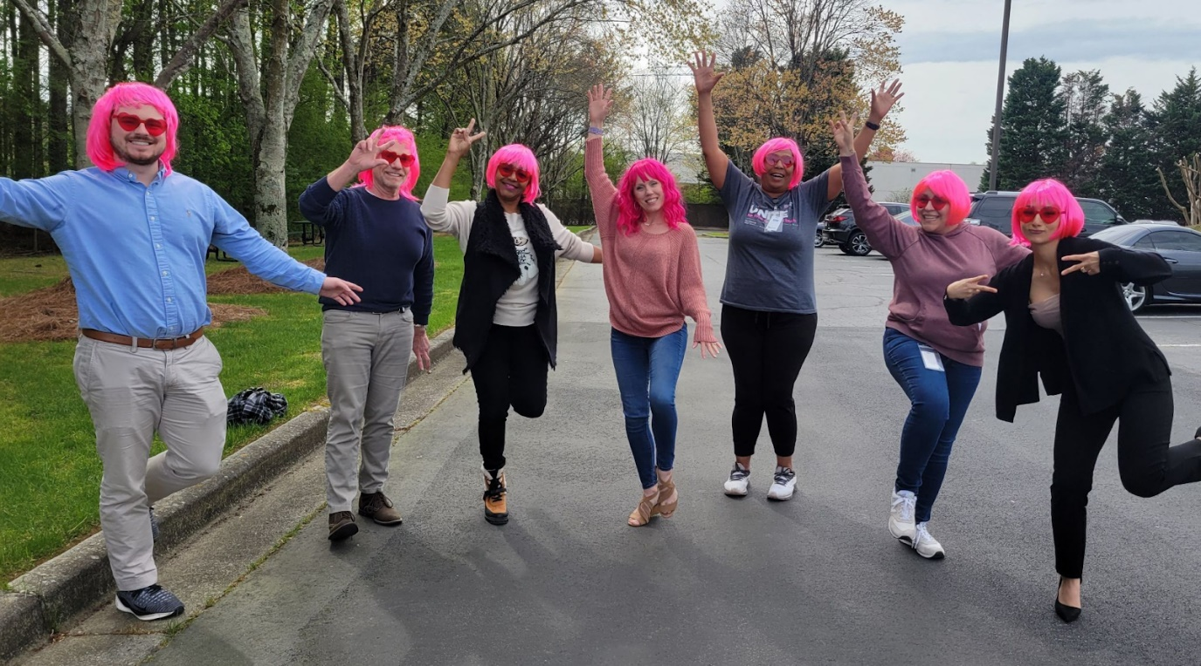
We are so proud of our dedicated team who embody our values of reliability, teamwork, and leadership by participating in on-site events and fundraising for donations.

Best Buddies International
Crown Asset Management was honored to participate in the Best Buddies Champion Gala on October 20th in Atlanta, GA. All funds raised at the Gala benefit Best Buddies – the world’s largest organization dedicated to ending the social, physical and economic isolation of the 200 million people with intellectual and developmental disabilities (IDD) through programs that help them form meaningful friendships with their peers, secure successful jobs, live independently, improve public speaking, self-advocacy and communication skills, and feel valued by society.
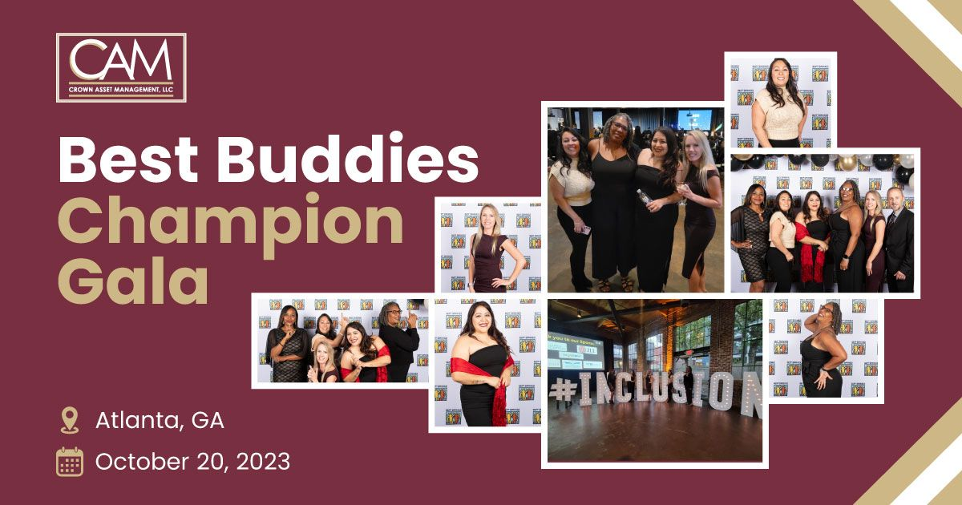
The Crown Asset Management team also participated in the Best Buddies Friendship Walk, an annual event that takes place in various locations across the country. Participating in the Friendship Walk served as an excellent team-building and service opportunity. Together, the Crown Asset family supported a cause that aligns with its core values of integrity and respect, creating friendship opportunities, integrated employment, leadership development, and inclusive living for people with IDD.
The event also allowed Crown Asset Management to connect with other local businesses and organizations, promoting unity, collaboration, and excellence as the team joins other companies in their commitment to giving back. Crown Asset Management wholeheartedly extends sincere appreciation to everyone who has championed the cause of Best Buddies in Georgia, with a special mention to the top fundraisers and teams.
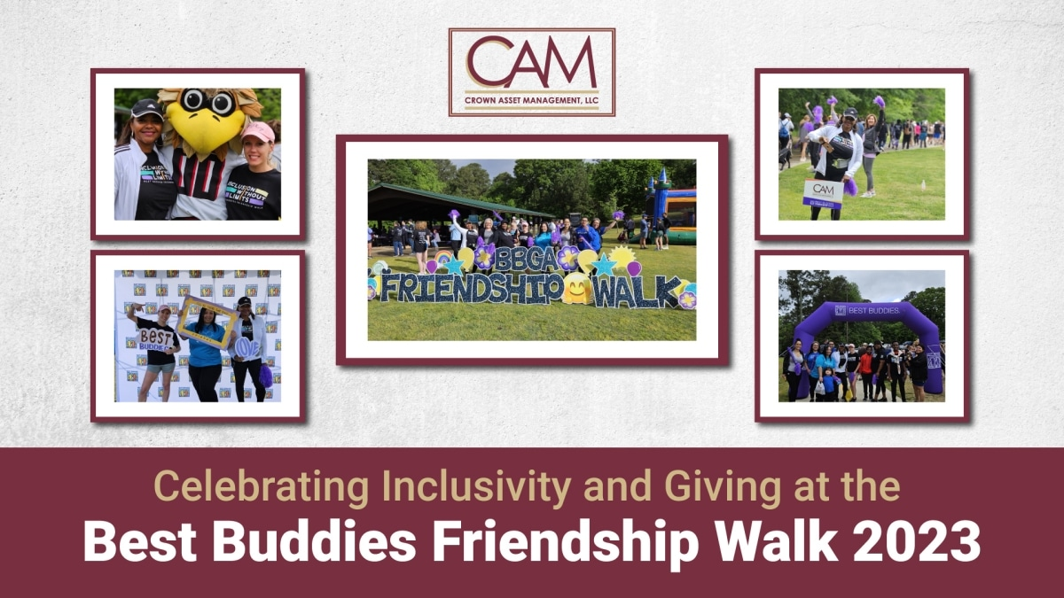

Habitat for Humanity
In September 2023, the Crown Asset Management team partnered with the Gwinnett / Walton Habitat for Humanity organization to take part in a volunteer build day in Loganville, GA. The weather was perfect and the team showed up in full force— a true show of dedication and reliability— to demonstrate the power of teamwork and community!
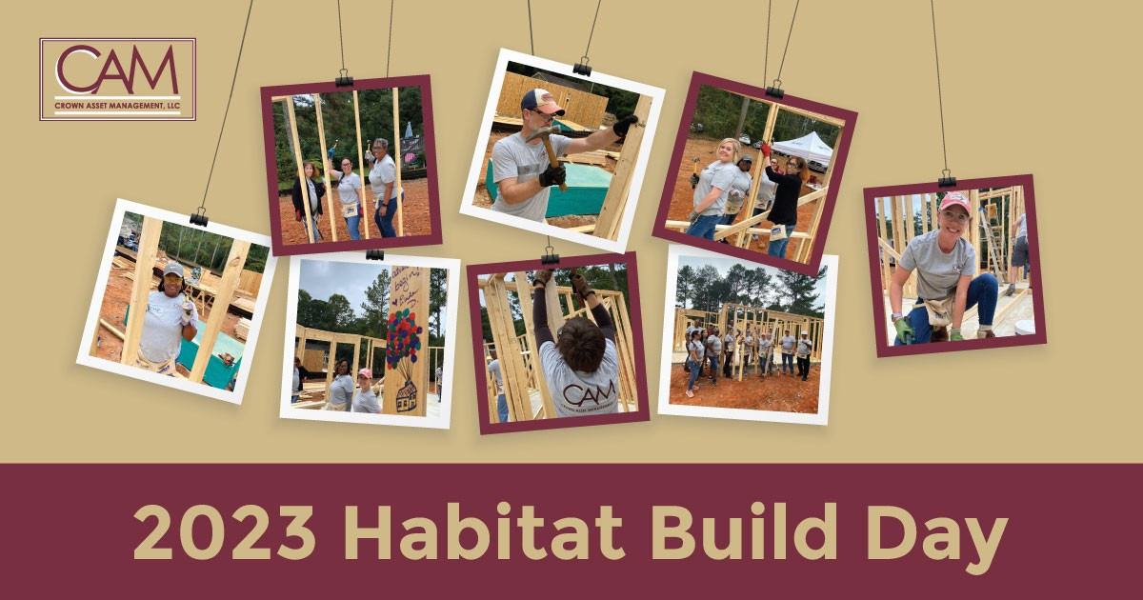

“It was a highly successful day and I couldn’t be more proud of our team for their hard work in making it a worthwhile effort. It is always rewarding to join together and use the combined power of teamwork and work ethic to make an impact right here in our community. We were honored and privileged to have the opportunity to take part in building the future home of a local hard working family who was carefully selected and extremely grateful as the recipients of this new home,” said Brian Williams, CEO at Crown Asset Management.
It was a true honor to later witness the family home dedication in December, 2023. Chris McGill and Linda Dameron accepted a plaque on behalf of Crown Asset Management for the ceremony. Partnering with Habitat for Humanity in helping build the family home was an empowering experience that epitomizes the very essence of the company’s values of integrity and teamwork.
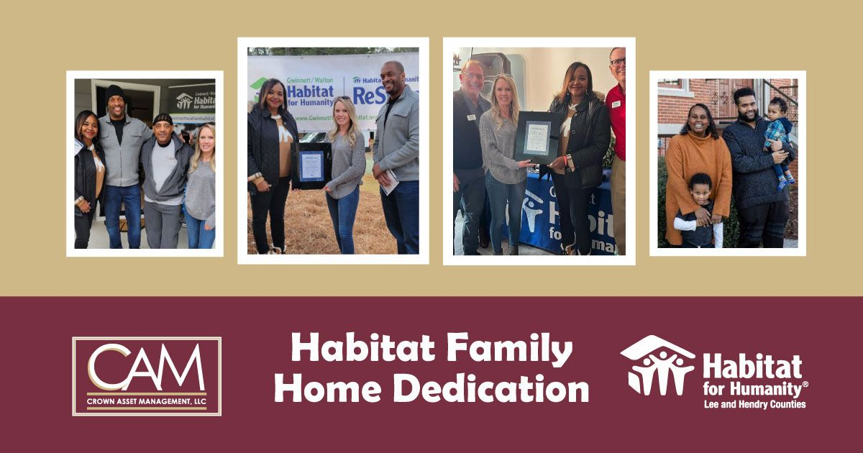

Teamwork Builds a Healthy Organization
Teamwork lies at the heart of Crown Asset Management's collective impact strategy. Collaboration is essential, and the company aims to always foster synergy among team members, partners, and community stakeholders. Through shared goals and collaborative efforts, Crown Asset Management maximizes its effectiveness in driving positive change.

Leadership Above All Else
Leadership is not merely a role but a responsibility embraced by Crown Asset Management. Setting an example through advocacy and empowerment, the organization hopes to inspire others to join in its mission of making a difference. Guided by its core principles, Crown Asset Management endeavors to be a leader in corporate citizenship, setting a standard of excellence for social responsibility within its industry.
Because of the organization’s core values, and its commitment to the community at large, Crown Asset Management takes pride in the impact made thus far while remaining humbled by the opportunities to serve. Together with its partners and stakeholders, Crown Asset Management strives to build a brighter future for all—a future guided by excellence, integrity, reliability, respect, teamwork, and leadership.

About Crown Asset Management
Founded in 2004, Crown Asset Management, LLC, is a professional receivables management firm that specializes in the acquisition of non-performing accounts. The team, through its robust Compliance Management System, prioritizes compliant collection efforts and the ethical treatment of its consumers across its outsourced servicing (or Servicer) platform. Crown Asset Management is an RMAI Certified Receivables Business headquartered in Duluth, GA.

