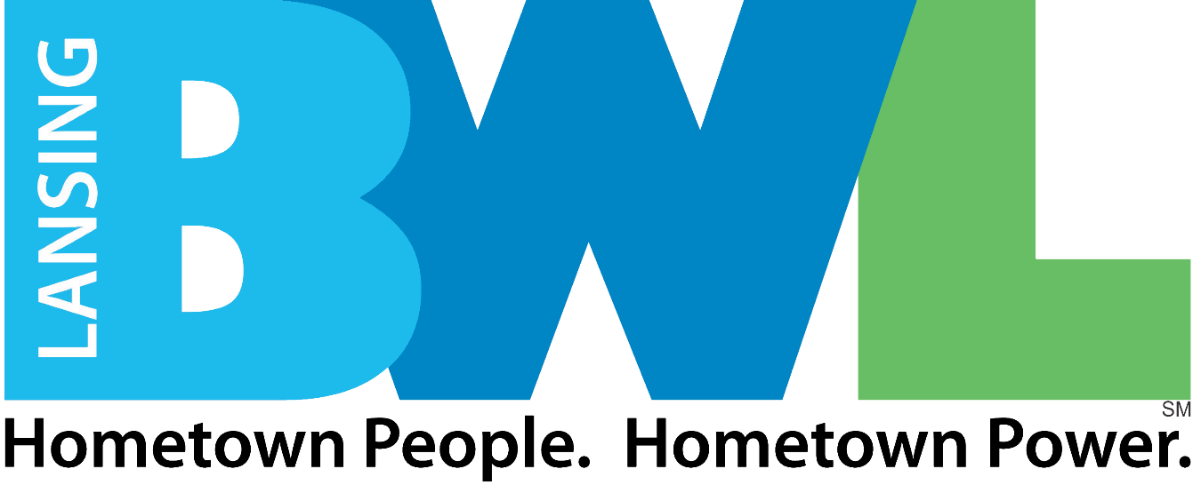

***1.31.25 @ 4:00 PM* local time**

**Submission Deadline:**

**12.23.2024**

Request for Proposal

Scope of Work: Overdue Billing/Payment Servicing Solution

Contents

Section 1: Project Overview 4

1.1 Board of Water and Light Background 4

1.2 RFP Objectives 4

1.3 Project Scope of Work 4

1.4 Deliverables 4

1.5 BWL’s Current Systems and Infrastructure 5

1.6 Glossary of Terms 5

Section 2: Instructions to Proponents 6

2.1 Key Dates 6

2.2 Instructions to Complete Requirements 6

Section 3: Proponent Company and Product Overview 7

3.1 Executive Summary 7

3.2 Overview of Proposed Solution 7

3.3 Proponent Company Information 7

3.4 References 8

3.5 Detailed Description of Services 8

3.6 National Standards 8

3.7 People 8

3.8 Pricing 8

3.9 Proponent Comments 8

Section 4.0: Evaluation Criteria 8

Appendix A: Current System Diagrams 10

Appendix B: Detailed As-Is Process Diagrams 11

Appendix C: Bill Sample 12

# Section 1: Project Overview

## 1.1 Board of Water & Light Background

The Lansing Board of Water & Light (BWL), founded in 1885 and is the largest municipally owned electric utility in Michigan and among the 30 largest in the United States. An eight-member Board of Commissioners appointed by the mayor and confirmed by the Lansing City Council governs the BWL which employs approximately 800 people. BWL has production facilities for all commodities supplied. BWL is a transmission and distribution owner/operator, provides wholesale water and electric, and interacts with Midcontinent Independent System Operator (MISO).

BWL owns and operates:

* An electric system, that generates, purchases, and distributes electric power, and provides electric service to approximately 99,000 residential, commercial, and industrial customers in the greater Lansing, Michigan area.
* Water wells, a raw water transmission system, water conditioning facilities, and an extensive water distribution system serving potable water to approximately 58,000 residential, commercial, and industrial customers in the greater Lansing area. In addition, approximately 42,000 of these customers receive non-metered sewage services.
* Steam generation boilers, a steam transmission and distribution system serving approximately 160 customers, and a chilled water facility and distribution piping system serving 19 customers in the city of Lansing.

Additional BWL background and information may be viewed at [www.lbwl.com](http://www.lbwl.com).

## 1.2 RFP Objectives

BWL is seeking a solution for the facilitation of the collection and payment of overdue utility bills. By leveraging meter interval deliver a communication strategy to facilitate collection of bills that have exceeded the standard payment time window. The solution should employ machine learning and/or Artificial Intelligence to analyze and predict customer behavior based on payment history aligned to the bill remittance/collection cycle. Through a communication delivery that reflects customers’ preference, deliver messaging to facilitate bill payment up to and including service shutoff. Using data from the Customer Information System (CIS) and employing current BWL or proposed notification systems, deliver communication that fosters the payment of bill exceeding payment terms. When doing so the system will encourage and support the payment through digital channels including providing services that aren’t necessarily available and/or used by the under- banked.

## 1.3 Project Scope of Work

Program Development & Modeling

Design and build a proposed solution to cause delinquent in paying customers a mechanism to pay overdue bills through a strategy that directly communicates to the customer and provides a mechanism to cause customers to resolve their utility charges. The modeling should include:

* Communication scenarios
  + Develop scenarios & test for most effective communication channels
  + Deploy trained model based on scenario results
* Data quality/cleansing
  + Validation customers’ bill payment status prior to outreach
  + Ability to identify and/or address data issues in the communication channel
* Implementation
  + Using historical billing data, develop the model against BWL customer behaviors
  + Refine the model via targeted variations impacting customer behavior
  + Through the model, the best strategy solution is determined
* Define roles, cooperation
  + Specify the roles and responsibilities required to support the determined model

Data Collection Results & Analysis

Test the proposed model on a subset of BWL customers to gauge response. Vendor to provide analytics of model tests for documenting results including forecasts on the ability to reduce overdue bills. Activities include but are not limited to:

* Run **scenarios, sma**ll groups Testing
* Analyze behavior
* Make incremental changes for ‘tweaking’ the model

Modeling Refinement to BWL Customer Response

From the model test results, refine the model to increase customer awareness through a customized communication strategy and payment alternatives that promote overdue bill reduction. Elements of the deployed strategy could include:

* Communication Methodology Strategy
  + Time of reminder
  + Communication channel
  + Tone of voice
* Billing/Payment Alternatives Strategy
  + E-bill adoption
  + Payment of bill
  + Take rate on payment arraignments (BWL offerings as well as any additional vendor-propose payment plan)

Implementation

Based on the model testing results, deploy the solution across the BWL portfolio refining through:

* Launch model beyond test groups (incrementally or full, vendor recommendation requested)
* Develop and align BWL-centric process flows
* On a regular basis (≈ every 9-12 months) reassess the model for enhancement

Reports and/or Administrative Dashboard

## Systemic methodology for the monitoring of solution activity. Parameters could include:

## Communication activity

## Payment methodology take rate

## Financial results of overdue debt collection

## Technology Standards & Requirements

In the response, summarize the solutions ability to address the below BWL technical requirements.

* Encryption methodology: Any files that contain customer PII, customer sensitive data, or any data that may fall under a regulatory scope (e.g., NERC/NERC-CIP, HIPAA, PCI) must be encrypted both in transit and at rest. While in transit, data shall be transmitted using the TLS 1.2+ cryptographic protocol with a strong cipher suite. Files are required to be encrypted using PGP.
* Data storage capabilities.
* Data retention policies including disposal process/policies and data lifecycle.
* Access management processes.
* Batch process automation including failure/anomaly handling with available/recommended processes and methods for handling failures (e.g., file transfer failures, decryption errors, etc.).

## 1.4 Project Deliverables

BWL expects to receive the following:

1. Project Kick-off meeting with presentation
2. Project management plan and project schedule
3. Weekly project status meetings
4. Status reports every two weeks during implementation of the project
5. Design documents including network and architectural diagrams
6. New software system configured and operational in Development, Test and Production environments
7. Technical documentation on the configuration of the software
8. Technical documentation of the configuration of the equipment
9. Test Plan with input and data requirements
10. System test results
11. User documentation
12. Production Transition Plan
13. Production Transition training session(s)

## 1.5 BWL’s Current Systems and Infrastructure

The table below lists relevant systems used by BWL.

| **System** | **Vendor/Product** |
| --- | --- |
| Customer Information System | Itineris/UMAX |
| Financial Management System | SAP/Business Suite 7/ EHP7 FOR SAP ERP 6.0  AP ERP 6.0  SAP NETWEAVER 7.4 |
|  |  |

## 1.6 Glossary of Terms

1. **BWL**: Lansing Board of Water & Light.
2. **CIS**: Customer Information System.
3. **CSS**: Customer Operations Systems Support.
4. **ESB**: means Enterprise Service Bus used at BWL for system interfaces.
5. **Proponent**: means the party proposing a solution to this Request for Proposal (RFP).
6. **RFP**: this Request for Proposal document.
7. **SLA**: Service Level Agreement.
8. **Vendor**: the Proponent that is submitting a Proposal for this RFP.

# Section 2: Instructions to Proponents

## 2.1 Key Dates

Below is the estimated timeline that BWL will follow during the evaluation of the RFP responses. BWL reserves the right to adjust these dates as required at BWL’s sole discretion. All Proponents will be notified if any of the dates are altered after issuance of this RFP. Proponents are expected to propose the time needed to develop, test, and implement their proposed solutions.

| **Event** | **Date** |
| --- | --- |
| Release RFP | 12.23.2024 |
| Closing date for RFP submission | 1.31.2025 |
| Vendor Selection | 2.28.2025 |
| Negotiations and Contract Work | 3.1.2025-3.31.2025 |
| Contract Finalized/Discovery Sessions and Design | 4.1.2025-4.18.2025 |
| Development begins | 4.21.2025 |
| Go-live | 7.28.2025 |
| Hypercare | 7.28.2025-8.15.2025 |
| Post Go-live Support for model updates | Every 9-12 months after Go Live for life of contract |

## 2.2 Instructions to Complete Requirements

This is a request for proposal regarding the proponent’s offerings for overdue billing/payment solution. Information provided in the RFP and the respondent’s proposal will be included in final Statement of Work during final contract negotiations. Items in Section 3 below will provide a foundation for the evaluation but is not all inclusive.

# Section 3: Proponent Company and Product Overview

## 3.1 Executive Summary

Please provide an executive summary (one page maximum) that summarizes the Proponent’s response. Please include the following information:

1. Full company name
2. Company address
3. Designated representative for this RFI: name, e-mail address and phone number

## 3.2 Overview of Proposed Solution

1. Highlight key features that differentiate the Proponent and the Proponent’s solution from those of competitors. Identify any unique approaches or strengths of the Proponent.
2. Describe your services and offerings as the relate to this RFP.

## 3.3 Proponent Company Information

To ensure long-term viability and maintenance of the system, the selected Proponent must be a proven vendor in IVR and AI technologies with dedicated ability to handle calls in the tens of thousands at one time. The Proponent is asked to answer the following questions intended to help BWL evaluate Proponent’s experience delivering and supporting the products and services that will be required by the future RFP.

1. Describe the Proponent’s primary line of business.
2. How long has the Proponent been delivering the services described in 3.2.2?
3. Outline the Proponent’s experience integrating systems listed in 1.3 as well as other system integrations.
4. Identify any Proponent industry partners.
5. Describe the Proponent’s positioning in the market.
6. Please describe your corporate structure (diagram and dialog)
7. Identify the Proponent’s strategic industry advantages/partnerships.

## 3.4 References

Provide a minimum of three (3) references (contact names, phone numbers, and e-mail addresses) for the Proponent’s recent customers (for the last three years) where the Proponent has delivered system integration services like this scope of work. For each reference, specify the exact services offered from your portfolio. Utility References are preferred.

## 3.5 Detailed Description of Services

Please provide details about the products and services you provide during the requirements finalization, development, testing, implementation, and post-go-live support periods. Marketing material may be sent to augment this section.

## 3.6 National Standards

Please provide a detailed list of standards you follow such as national standards on data control, encryption, or other standards and how the standard is specifically applies to this work. It is anticipated the system will be a 2D barcode based on the AIAG B-3 Bar Code Symbology Standard for parts and shipping. Proponents may propose alternatives with an explanation of the advantages and disadvantages of the proposed alternative.

## 3.7 People

Please provide an overview of your human support structure for client services, technical services, trouble shooting, implementation, testing, and post go-live support.

## 3.8 Pricing

Please provide your Firm Fixed Price (FFP) bid for this work for deploying the solution with associated operating costs for system operation.

## 3.9 Proponent Comments

Please feel free to include any other information you feel will assist BWL in selecting a provider.

Section 4.0: Evaluation Criteria

The following are evaluation criteria (in no order) may be applied in awarding this contract to the successful Proponent. BWL reserves the right to change or evaluate on additional criteria at the it’s sole discretion.

* Price
* Experience providing similar implementations
* Adequacy of staffing plan
* Amount of time to complete the work
* Adequacy of project management and productivity monitoring plans
* Vendor’s technical proposal for integrating BWL instance of SAP
* Adequacy of post go-live support plan
* Adequacy of production turnover plan
* Proposed personnel.